1.Create a table listing 3 types of printers, 2 types of scanners, and 2 types of webcams, and for each, write one real-life use case (for example: 'Inkjet printer – printing college assignments').

Device Type | Type | Real-Life Use Case
Printer | Inkjet Printer | Printing college assignments and project reports.
Printer | Laser Printer | Printing office documents quickly in large quantities.
Printer | Dot Matrix Printer | Printing bills and receipts in shops and banks.
Scanner | Flatbed Scanner | Scanning certificates and photographs for digital storage.
Scanner | Sheet-fed Scanner | Scanning multiple pages of documents in offices.
Webcam | Built-in Webcam | Attending online classes and video meetings.
Webcam | External USB Webcam | Video streaming and making high-quality video calls.

2.Draw a labeled diagram showing how a typical home printer connects to a laptop or PC, including the connection interface used (USB, Wi-Fi, or Bluetooth).

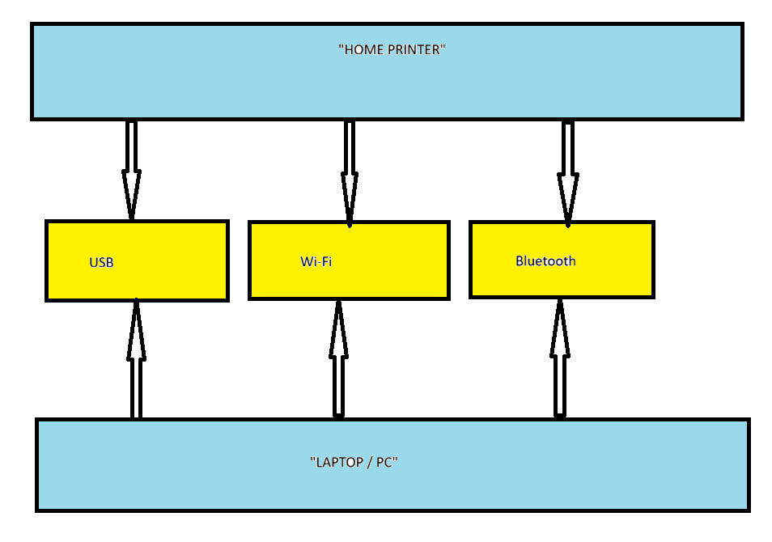
3.List three different connection interfaces (such as USB, Wi-Fi, Bluetooth) used by peripherals like printers, scanners, and webcams, and for each, name one advantage and one disadvantage.<br><br><em><strong>Hint:</strong> Think about speed, convenience, and compatibility.</em>

Connection Interface | Advantage | Disadvantage
USB | It provides a fast and stable connection and is easy to use. | A cable is required, so the device cannot be used from far away.
Wi-Fi | It allows wireless connection and multiple users can access the device. | It depends on network strength and may become slow if the signal is weak.
Bluetooth | It is convenient for short-distance wireless connections and uses less power. | It has a limited range and slower speed compared to USB.

4.Pick any one device you use at home or college (printer, scanner, or webcam). Write step-by-step instructions for how you would connect it to your computer, including what cable or wireless method you would use and any setup steps required.

Device Chosen: Printer (USB Connection)
Steps to connect a printer to my computer:
- First, I make sure that the printer is plugged into the power socket and switched on.
- Then, I connect the printer to my computer using a USB cable.
- After connecting the cable, the computer usually detects the printer automatically.
- If required, I install the printer driver using the CD provided with the printer or download it from the printer manufacturer's website.
- I open the computer settings and check whether the printer appears in the Printers & Scanners section.
- Finally, I print a test page to make sure the printer is working properly.

